***Pityopsis -* Silkgrasses**

Gage Lapierre, Michael Andreu, Jazz Griffis

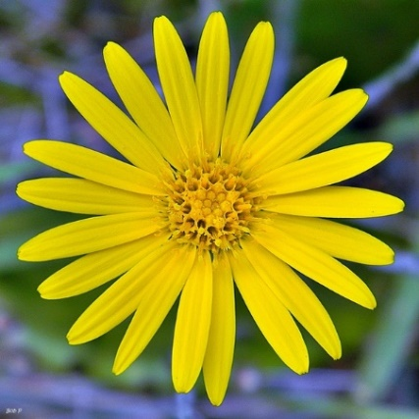 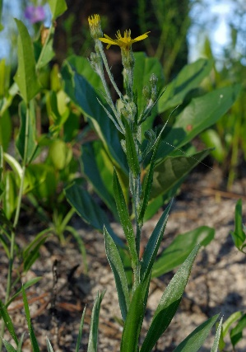 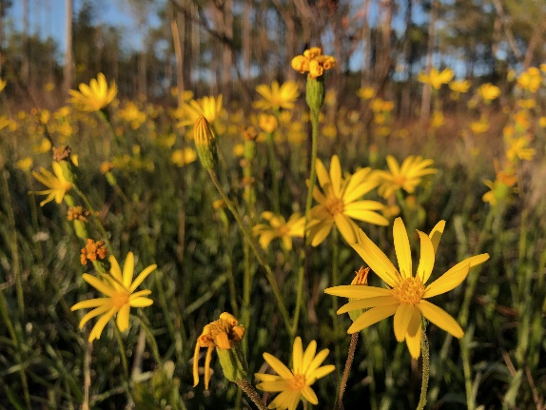

**Taxonomy**

**Family** — *Asteraceae* (Asters) **Genus** — *Pityopsis* (Silkgrass)

**Common Name** — The name “silkgrass” arose from its grass and silk like appearance of the leaf foliage.

**Description**

The genus *Pityopsis*, or silkgrasses as they are commonly called, are perennial forbs that are grass-like in appearance and feature silver silk-like hairs. Historically only four species of silkgrass were recognized. Recent phylogenetic work has determined that there are at least nine distinct species of silkgrass that are native to Florida. These include *Pityopsis aequilifolia*, *P. aspera*, *P. flexuosa*, *P. graminifolia, P. latifolia*, *P. microcephala*, *P. nervosa*, *P. oligantha*, and *P. tracyi*  (Weakley et al. 2018, Nesom 2019, Semple & Jabbour 2019).

Each species is found within certain geographic boundaries and natural communities in Florida. Recognizing these different species is important for land managers who are striving to restore specific plant communities. As well as nursery growers where native plant materials are being sold and distributed throughout the state. Academic botanical keys make identification of these nine species challenging for those without botanical background. This guide aims to alleviate this challenge by providing pictures and illustrations of each species.

leaflet

**Figure 1.** Species of silkgrass can be divided between those that feature basal leaves that are longer in length than the stem leaves and those that are shorter.

**Basal Leaves Longer than Stem Leaves**

*P. aspera*

*P. graminifolia*

*P. microcephala*

*P. oligantha*

*P. tracyi*

**Basal Leaves Shorter than Stem Leaves**

*P. aequilifolia*

*P. falcata*

*P. flexuosa*

*P. latifolia*

**Figure 2.** Guide for botanical terminologies useful for species of Pityopsis.

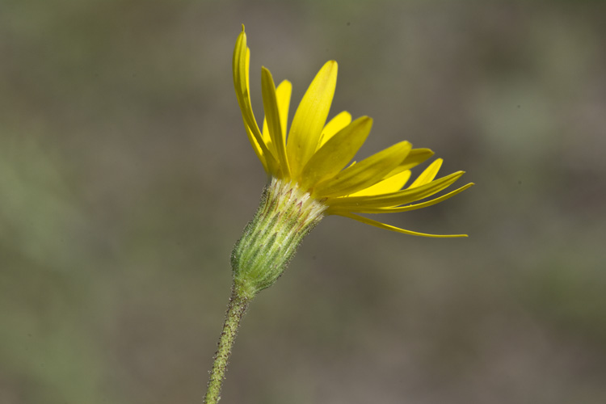

**Flower Head**

**Peduncle**

**Phyllaries**

**Disc Florets**

Photo Credit: (left) by tomkennedy, Apalachicola National Forest, FL (https://www.inaturalist.org/observations/104951955)[ CC BY-NC], (right) by Port St Joe, FL (https://www.inaturalist.org/observations/42929070) [CC BY].

**Pratitical Guide to Differiating Silkgrass Species in Florida**

***Pityopsis aequilifolia* (Scrub Silkgrass)**

Distinguishing Characteristics: Dense ascending non-falcate (non-hooked shape) leaves. Less than 30 disc florets. Cespitose (bunching) growth habit; it is one of the few species of *Pityopsis* that are not rhizomatous (creeping roots). Found in scrubs and sandhills in central peninsula of FL.

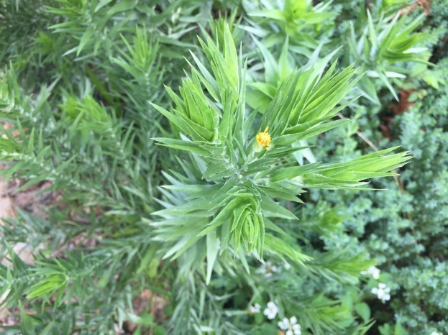 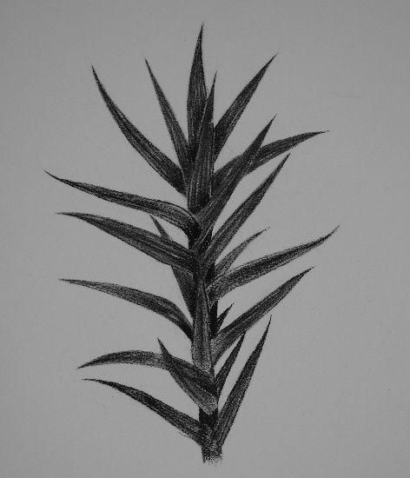

Photo Credit: (left) Edwin Bridges [CC BY-NC], (middle) by philanderin, Eustis, FL (https://www.inaturalist.org/observations/128828829)[ CC BY-NC], (right) illustration by Jazz Griffis [All rights Reserved].

***Pityopsis aspera* (Pineland Silkgrass)**

Distinguishing Characteristics: Hairy pubescent leaves (< 10 mm wide), stems, peduncles, and phyllaries. Basal leaves are much longer than stem leaves. Found within sandhills and mesic flatwoods within the panhandle and north pensiula of FL. There are two varieties of this species which include *P. aspera* *var. adenolepis* and *P. aspera var. aspera*. The primary distinguishing feature between these varieites is the presence of glands along the stems; *P. aspera* *var. adenolepis* has no stem glands whereas P. aspera var. aspera does.

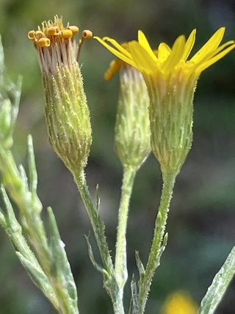 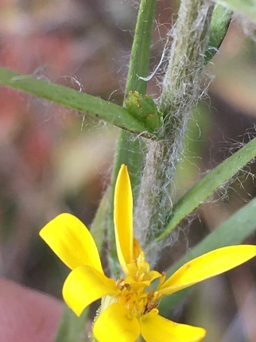

Photo Credit: (left)(middle) by gillydilly, Wadesboro, NC (https://www.inaturalist.org/observations/122838548)[ NC], (right) illustration by Jazz Griffis [All Rights Reserved].

***Pityopsis falcata* (Sickleleaf Silk-Grass)**

Distinguishing Characteristics: Falcate (non-hooked shape) leaves that diverge from the stem. Basal leaves are shorter or equal to stem leaves. This species is native to North America but is not native to FL. It features limited localized naturalization near Tampa, FL.

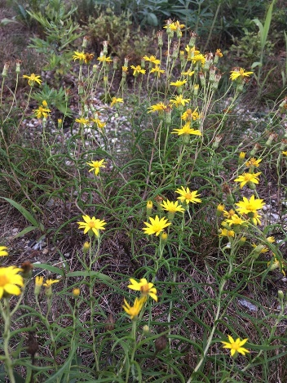

Photo Credit: (left)(center) Public domain [NC], (right) illustration by Jazz Griffis [All Rights Reserved].

***Pityopsis flexuosa* (Zigzag Silkgrass)**

Distinguishing Characteristics: Stems that are bent or zigzag from each node. Basal leaves are shorter or equal to its stem leaves. Found in sandhills within the western half of the FL panhandle region.

Photo Credit: (left) by , (middle) by torreya_trekker, Tallahassee, FL (https://www.inaturalist.org/observations/58652386] [CC BY-NC], (right) illustration by Jazz Griffis [All Rights Reserved].

***Pityopsis latifolia* (Broadleaf Silkgrass)**

Distinguishing Characteristics: Basal leaves are oblanceolate (rounded leaf) and are shorter than the the stem and upper leaves. Disc florets exceed 30 per flowering head. This species is found only within Florida xeric white sand scrub in central and south pensiula FL.

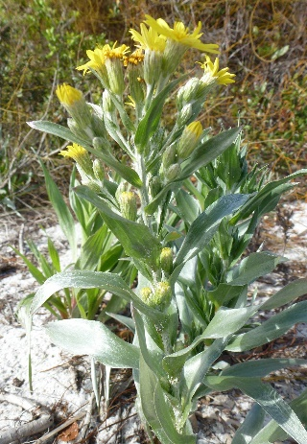 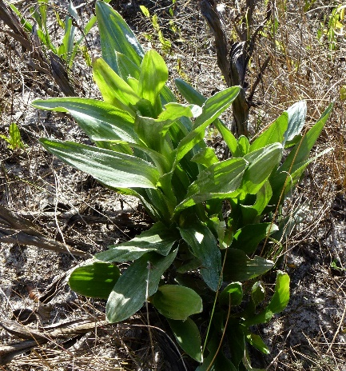

Photo Credit: Edwin Bridges [CC BY-NC], (right) illustration by Jazz Griffis [All Rights Reserved].

***Pityopsis graminifolia* (Narrowleaf Silkgrass)**

Distinguishing Characteristics: The peduncles, upper stems, and phyllaries feature few to no glands. Less than 30 disc florets (flower heads) per stem. The stem leaves only slightly overlap, and overall there are fewer stem leaves when compared to *P. aequilifolia*. The basal leaves are much longer than the stem leaves as well. Found within the panhandle and peninsula region of FL.

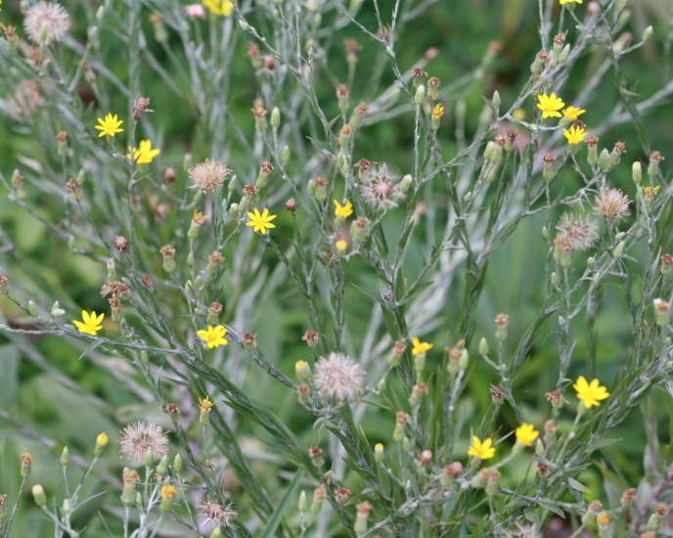 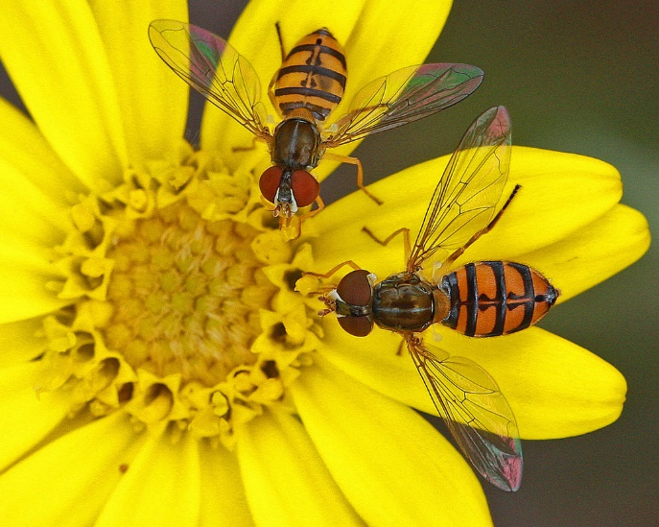

Photo Credit: (left) (middle) by marykeim, Orange County, FL (https://www.inaturalist.org/observations/4019133) [CC BY-NC-SA], (right) illustration by Jazz Griffis [All Rights Reserved].

*Species *P. graminifolia, P. microcephala*, and *P. nervosa* are all extremely alike to one another. All three species occur within the same habitats. *P. graminifolia* is generally thought to be less common than *P. microcephala* and *P. nervosa*. Historically, *P. microcephala* was treated as *P. graminifolia var. tenuifolia*, whereas *P. nervosa* was treated as *P. graminifolia var. latifolia*. All three species are primarily differentiated based on the structuring of their phyllaries.

**Pityopsis oligantha (Bog Silkgrass)**

Distinguishing Characteristics: Less than ten flowering heads per stem. Basal leaves are much longer than the stem leaves. The only *Pityopsis* species that is found principally in wet soils. Restricted to seepage slopes, wet flatwoods, wet prairies, and the margins of cypress domes and marsh communities.

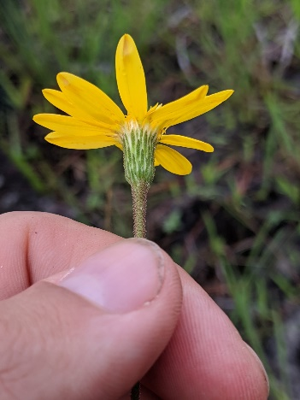**

Photo Credit: (left) by scottward, Apalachicola, FL (https://www.inaturalist.org/observations/74833879) [CC-BY-NC], (middle) by torreya_trekker, Port St Joe (<https://www.inaturalist.org/observations/42929070>) [CC-BY], (right) illustration by Jazz Griffis [All Rights Reserved].

**Pityopsis tracyi (Tracy's Silkgrass)**

Distinguishing Characteristics: Disc florets exceed 30 per flowering head. This species is often regarded as the most robust species of *Pityopsis* in FL. Flowering heights often range from 50-100 cm. Basal leaves are large ranging from 15-30cm long.

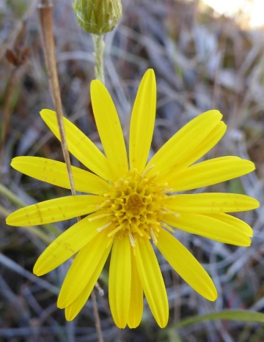 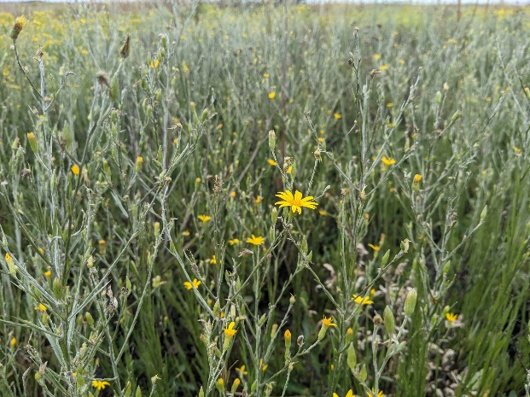

Photo Credit: (left) by edwinbridges, Charlotte County, FL (https://www.inaturalist.org/observations/19986274) [CC-BY-NC], (middle) by natemartineau, Highlands, FL, (https://www.inaturalist.org/observations/102679642)[CC-BY-NC]

**Notes on Phenology**

Generally, the growth of silkgrasses start slowly in the spring and accelerates in warm weather during the summer months. Typically, silkgrasses will flower in Florida from September through November periods. However, it is not unusual to see populations flowering during spring and summer months. In Florida the seed from silkgrass species will often mature in November to January. The seed in wild germinates during winter months following rains from cold fronts. Both the phenology and growth habit of this species is greatly affected by the seasonal timing of fire. Several studies conducted by Stephen Brewer and William Platt found that fire during the late-spring and summer periods induces a higher rate of flowering, a greater number of shoots/clones, improved seedling emergence, and increased overall fecundity in comparison to winter fires. As a result, land managers and seed producers may see an increase in silkgrass stand health and seed production from periodic burning (or cutting) during those periods.

**Applications**

All silkgrass species except for *P. aequilifolia* are rhizomatous, making them well suited for use in erosion control and rehabilitation of sites affected by mining and overgrazing. The capacity for high seed production and viability makes silkgrasses ideal for use in groundcover restoration and enhancement projects as well.

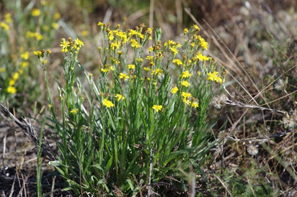

Photo Credit: (left) [NC], (right) vita-sativum, Orlando, FL, (<https://www.inaturalist.org/observations/36677857>) [CC-BY-NC]

**Forage**

Livestock and wildlife are known to graze silkgrass, especially directly following fires. However, this species is seldom in high enough abundance to support livestock long-term. Light grazing from wildlife or livestock though are not thought to greatly affect mortality of silkgrass.

Photo Credit: by debdee, St. Marks National Wildlife Refuge, Panacea, FL (https://www.inaturalist.org/observations/99004674) [CC-BY-NC]

**Wildlife**

The flowers and largescale blooms of silkgrasses often attracts and supports a wide diversity of pollinators (see Table 1). This includes mining bees, plasterer bees, wasps, bumble bees, sweat bees, leaf cutting bees, ground nesting bees, and many different species of moths, wasps, and butterflies. Silkgrasses are also a source of forage for grasshoppers, gopher tortoises, and whitetail deer, which are known to browse the buds of silkgrass, as well as the new growth following burns.

*Calephelis virginiensis Eurema daira Ammophila procera*

**

Photo Credit: (left) by Edwin Bridges, Highlands County, FL [CC BY-NC], (middle) by Steve Coleman, Leon County, FL (right) by Mary Keim, Lake Pickett, FL (https://www.inaturalist.org/observations/139294101) [CC BY-NC-SA].

**Table 1.** Species of pollinators currently known to interact with *Pityopsis graminifolia.*

|  |  |
| --- | --- |
| Family | Species |
| Andrenidae | *Andrena fulvipennis* |
|  | *Perdita blatchleyi, P. boltoniae, P. consobrina, P. georgica, P. graenicheri, P. octomaculata, Pseudopanurgus solidaginis* |
| Apidae | *Bombus impatiens,* *Melissodes dentiventris, Triepeolus atripes* |
| Colletidae | *Colletes mandibularis* *C. americanus* |
| Halictidae | *Agapostemon splendens, Augochlora pura, Augochloropsis anonyma, A. metallica, A. sumptuosa, Halictus poeyi, Lasioglossum miniatulus, L. nymphalis, L. pectoralis, L. placidensis* |
| Hesperiidae | *Eurema daira, Urbanus proteus* |
| Leucospididae | *Leucospis robertsoni* |
| Megachilidae | *Anthidiellum notatum rufomaculatum, A. perplexum, Anthidium maculifrons, Coelioxys octodentata, C. sayi, C. texana, Dianthidium floridiense, Megachile albitarsis, M. brevis pseudobrevis, M. georgica, M. inimica, M. mendica, M. petulans, M. pruina* |
| Nymphalidae | *Junonia coenia* |
| Sphecidae | *Ammophila procera, Bicyrtes capnoptera, Cerceris tolteca, Philanthus ventilabris, Prionyx thomae, Trypargilum clavatum johannis* |
| Vespidae | *Parancistrocerus salcularis rufulus, Stenodynerus beameri* |

**Urban Landscaping**

Silkgrasses feature benefits that make them widely employable for use in urban landscaping around homes, gardens, and meadows. Silkgrass foliage for example is unaffected by freezes and largely resistant to a wide variety of pests. All species feature a silky texture and aqua color that make them both unique and appealing addition in landscapes. The yellow flowers of silkgrasses are attractive and helps support a wide range of pollinators. Most species of silkgrass are adapted to sandy and sunny areas with soil conditions ranging from xeric to mesic. Most species can also tolerate disturbed or compacted soils to an extent. Their ability to be mowed periodically also make them an excellent option for urban meadows and human constructed grasslands.

**Image.** Landscaping border using *Pityopsis* *trayci*.

Photo credits from Ryan Robert [All Rights Reserved].

Silkgrass can be mowed and may benefit from annual biomass removal. Cutting back above ground stems that have senesced flowers will induce and increase the number of flowers for that season. Oftentimes this is done following the fall flowering season and during the winter or early-spring when seeds are released or utilized by wildlife. However, silkgrass may also be cutback or mowed in the late-spring and early-summer months to encourage floral synchronicity and proliferation of reproductive ramets that may lead to a greater number of fall flowers.

**Propagation**

Silkgrass is readily propagated by seed. Seeds should be collected when seed color is black and are easily removable from head. Seeds typically ripen and mature in Florida from late-October to December months; southern populations may ripen later into January. Strong winds from cold fronts may cause rapid dispersion of seeds. Collection of seeds can be effectively performed with a vacuum cleaner or leaf-vacuum. Seeds from wild populations have reported germination rates as high as 65% in the literature.

**Image.** (Left) Photo of seed harvester collecting farmed silkgrass species, (right) small battery powered vacuum debris box full of silkgrass seed.

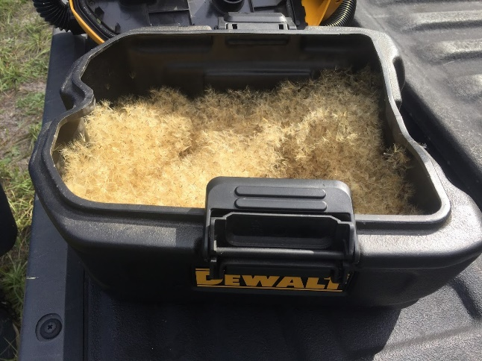

Photo Credit: (left) by John M Englert taken from Kujawski et al. 2001, (right) by Gage LaPierre [CC BY]

**Propagation Trial at UF Native Plant Nursery**

*Pityopsis trayci* was grown out from seed at the UF Native Plant Nursery in 2020-2021. The seeds were collected from Austin Cary Forest in November of 2020 and sown in March of 2021 light (12-hour photoperiod) exposure at 25/15 ºC. Seeds were sown via light press (1 cm depth) into a soil substrate consisting of peat, perlite, and vermiculite (5:3:2). The containers used were 2″ x 2⅛” x 1.5” in size manufactured by Anderson Pot Company. Exactly 123 seeds germinated out of 196 seeds (62% germination rate). Two weeks following germination plants were fertilized using 1 teaspoon of slow-release pellets of Osmocote Plus 15-9-12. After eight weeks plants were transplanted into one-gallon nursery pots (100% survival) and were ready for out-planting in another four weeks.

**Image.** (Left) *Pityopsis trayci* plant removed from starting pot after four weeks, (middle & right) silkgrass after twelve weeks in one-gallon pots.

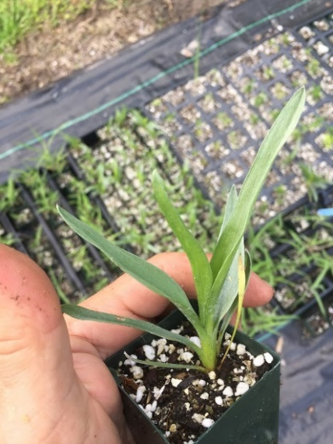

Photo credit: (left) (middle) (right) by Gage LaPierre at University of Florida [CC BY]

**References**

1. Aldrich, J. H. & Norcini, J. G. Tolerance of four container-grown native wildflower species. (2015).
2. Brewer, J. S. & Platt, W. J. Effects of fire season and herbivory on reproductive success in a clonal forb, *Pityopsis graminifolia*. The Journal of Ecology 82, 665 (1994).
3. Brewer, J. S. & Platt, W. J. Effects of fire season and soil fertility on clonal growth in a pyrophilic forb, *Pityopsis graminifolia* (Asteraceae). American Journal of Botany 81, 805–814 (1994).
4. Brewer, J. S., Platt, W. J., Glitzenstein, J. S. & Streng, D. R. Effects of fire-generated gaps on growth and reproduction of golden aster (*Pityopsis graminifolia*). Bulletin of the Torrey Botanical Club. 123, (1996).
5. Brewer, J. S. The relationship between soil fertility and fire-stimulated floral induction in two populations of grass-leaved golden aster. Oikos.74, 45–54 (1995).
6. Bush, T. Plant Fact Sheet - *Pityopsis graminifolia*. USDA, NRCS, National Plant Materials (2000).
7. Deyrup, M., Edirisinghe, J., & Norden, B. The diversity and floral hosts of bees at the Archbold Biological Station, Florida (Hymenoptera: Apoidea). Insecta Mundi. 65, 521-544 (2002).
8. Gowe, A. K. & Brewer, J. S. The evolution of fire-dependent flowering in goldenasters (*Pityopsis* spp.). Journal of the Torrey Botanical Society. 132, 384–400 (2005).
9. Harshberger, J. W. & Small, J. K. Flora of the Southeastern United States. Bulletin of the American Geographical Society. 47, 699–705 (1915).
10. Kujawski, J., Englert, J., Dusty, D. & Ugiansky, R. J. Equipment Modifications for Harvesting Fluffy Seeds. Native Plants Journal**.** 2, 114–115 (2001).
11. Lindon, H. L. & Menges, E. Scientific note: Effects of smoke on seed germination of twenty species of fire-prone habitats in Florida. Castanea. 73, 106–110 (2008).
12. Semple, J.C. and F. Jabbour. 2019. Type specimens of Inula (*Pityopsis graminifolia*). Phytoneuron. 44, 553-557 (2019).
13. Simkin, S. M., Michener, W. K. & Wyatt, R. Plant Response Following Soil Disturbance in a Longleaf Pine Ecosystem. 128, 208–218 (2018).
14. Terry Zinn. Easy Wildflowers: Guide to Florida native wildflowers for landscapes. Florida Wildflower Foundation (2014).